 British Wheelchair Athletics Association 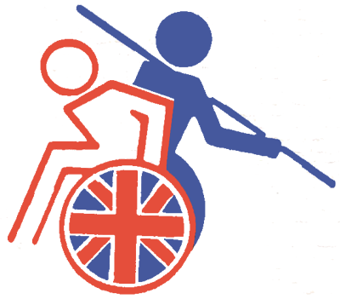

BWAA Grand Prix 2013 Grand Prix Date:

Name: Venue: Stoke Mandeville Stadium,

Address: Guttmann Road, Stoke Mandeville,

Bucks. HP21 9PP

E-Mail address:

Tel:

Mob:

Please enter your details. Tick the Grand Prix dates and Events you wish to compete in and your accommodation requirements.
Athlete Junior | B | Athlete Senior |  | Escort |  | Coach |  | Medical
Classification |  | F | T | Age |  | Sex |  | Official

Grand Prix Event | Shot |  | Discus |  | Javelin |  | Club

Grand Prix Dates | Field Programme and Events  Please Tick Events |  |  |  |  |  | Tick GP Dates  Field | Tick GP Dates Track
Grand Prix Dates | Sat 10.00am |  | Sat 2.00pm |  | Sun 10.00am
15 - 16th June 13 | Javelin / Club |  | Shot |  | Discus
6 - 7th July 13 | Discus |  | Javelin / Club |  | Shot
10 - 11th August 13 | Shot |  | Discus |  | Javelin / Club
7 - 8th September 13 | Javelin / Club |  | Shot |  | Discus

Track Events & Programme Enter personal best time in events you wish to enter
Events | 100m | 1500m | 400m | 200m | 800m
PB Time
Saturday approx | 10.00am | 10.50am | 11.15am | 2.00pm | 3.00pm

Hotel Accommodation:  Olympic Lodge, Aylesbury | Friday | Saturday | Sunday
Twin Room : £ 45.00 |  |  |  | £
Dormitory : £ 10.50 If available |  |  |  | £
Breakfast : £ 4.50 |  |  |  | £
Dinner : £ 6.50 |  |  |  | £
Entry Fee for the Weekend ( Athletes ) |  |  |  | £ 20 . 00
Total Amount Payable……. |  |  |  | £
If sharing, whom with:
Please return completed form with payment (Cheques payable to BWAA). Do not send Cash.
To: Mr Richard Schabel. 19 Newton Avenue. East Grinstead. West Sussex. RH19 4SW.
Tel: 01342 313692
Or Email: Schabel.rks@btinternet.com
TO BE RETURNED TWO WEEKS BEFORE THE EVENT

NO LATE ENTRIES WILL BE EXCEPTED

